**Whole Polymerase analysis**

**Tempest check**

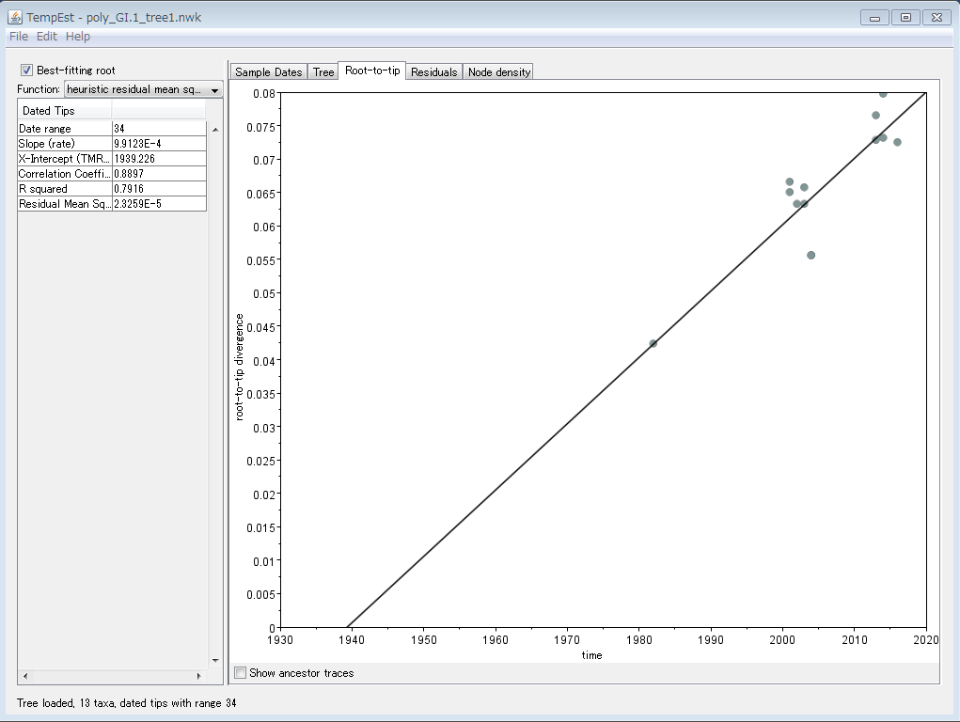

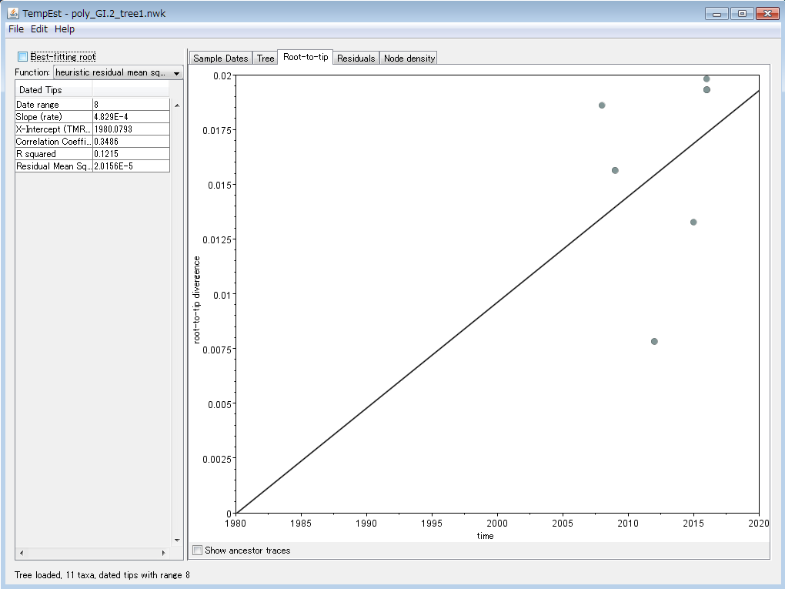

**Analysis of polymerase using TEMPEST**

**C:\Users\viro10\Desktop\KTE2_iroiro\GI.1 and GI.2 polym\GI.1\GI.1_polym_aa_n23_NJ_1000BS.nwk**

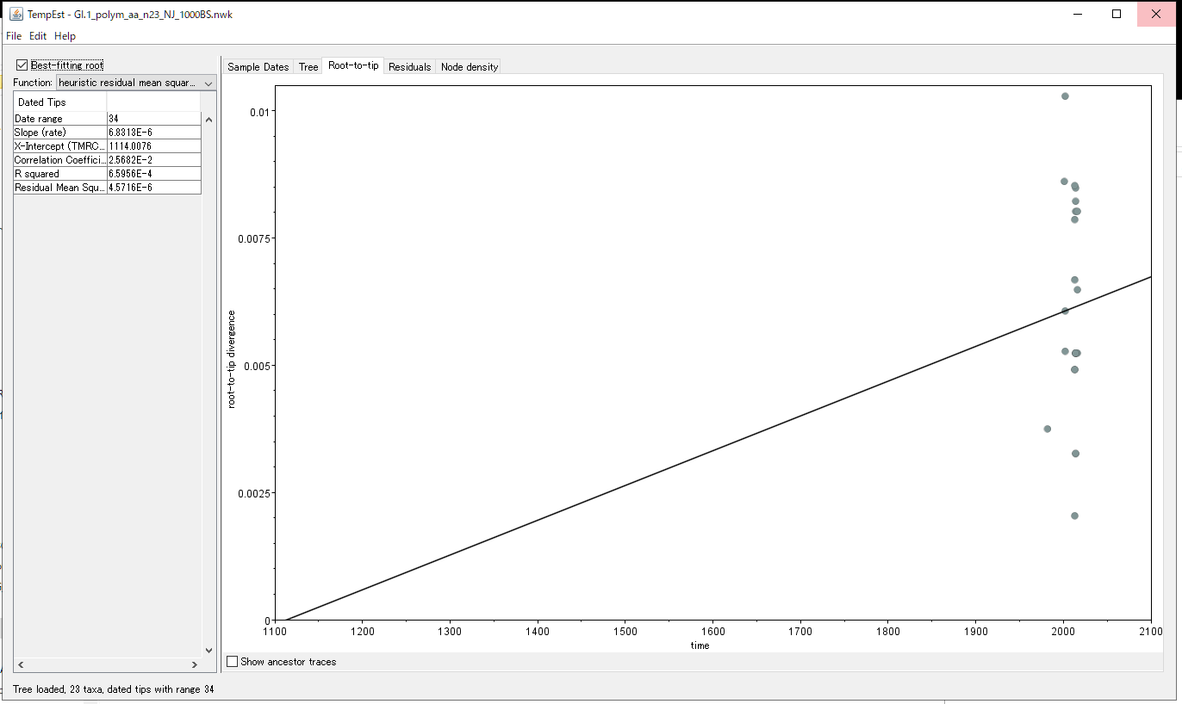

**C:\Users\viro10\Desktop\KTE2_iroiro\GI.1 and GI.2 polym\GI.2\GI.2_polym_n17_NJ_1000BS.nwk**

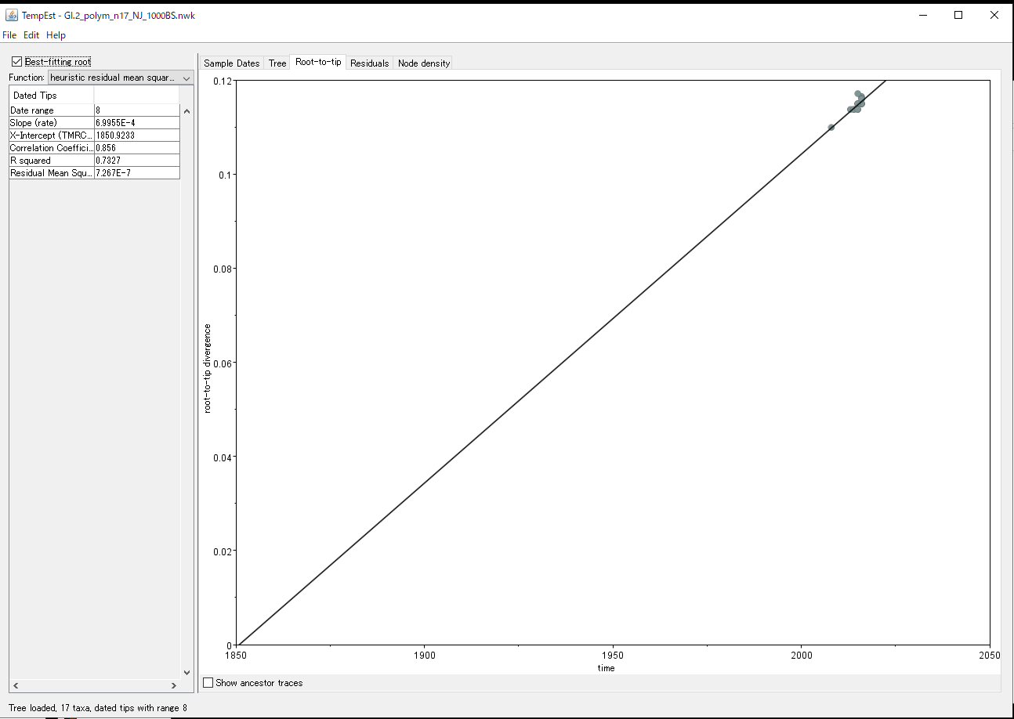

**There is enough phylogenetic signal to estimate molecular clock**

**Let us run BEAUTI using the aa files**

**GI.1_polym_n_23_aa_JTT+G_ok.fas**

**GI.2_polym_aa_JTT+G_n_17_OK.fas**

**Clock rate analysis for polymerase of sapovirus**

|  |  |  |  |  |  |  |
| --- | --- | --- | --- | --- | --- | --- |
| **Sapo genotype** | **Aligment type** | **Sample size** | **Number of generations** | **Clock type** | **Average evol rate** | **95%**  **HPD** |
| **GI.1** | **Amino acid** | **23** | **10000000** | **strict** | **3.04E-4** | **[1.19E-4, 5E-4]** |
| **GI.1** | **Amino acid** | **23** | **10000000** | **RCLN** | **3.13E-4** | **[1.18E-4,5.19E-4]** |
| **GI.1** | **Amino acid** | **23** | **50000000** | **RCE** | **5.1E-4** | **[1.2E-4, 9.7E-4]** |
| **GI.2** | **Amino acid** | **17** | **10000000** | **strict** | **1.39E-3** | **[1.5E-4, 3.05E-3]** |
| **GI.2** | **Amino acid** | **17** | **100000000** | **RCLN** | **2.3E-2** | **[4.6E-4, 5.67E-3]** |
| **GI.2** | **Amino acid** | **17** |  | **RCE** |  |  |

**While strict clock assumes that the evol rate is the same for all branches of a phylo tree, RCLN assumes that the evol rate varies across branches.**

**If we assume strict clock, we see that the polymerase of sapovirus GI.2 evolves faster than the polymerase of sapovirus GI.1, but the difference is not statistically significant. Even if we assume that the evol rate varies across branches, we still see a same evol rate for sav GI.1.**

**Comparison of clock rate for sapovirus GI.1 and GI.2 assuming strict clock**

The boxplot below and overlapping 95% HPD show that there is no significant difference of average amino acid substitution rate between sapovirus GI.1 and GI.2.

